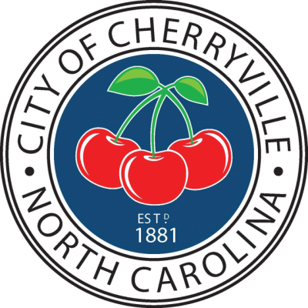

**The city council work session**

**meeting for**

**Tuesday July 30, 2024**

**has been cancelled.**

**If you have any questions or need**

**more information**

**please contact City Clerk**

**Paige Green**

**at 704-435-1709.**